ASSIGNMENT - 7

**CSP - 554 BIG DATA TECHNOLOGIES**

Exercise 1)

Step A: Use the TestDataGen program from previous assignments to generate new data files. Copy the files to HDFS.

Step B: Load the ‘foodratings’ file as a ‘csv’ file into a DataFrame called ex1_foodratings.

As the results of this exercise provide the magic number, the code you execute and screen shots of the following commands:

foodratings.printSchema()

foodratings.head(5)

Magic Number = 41641

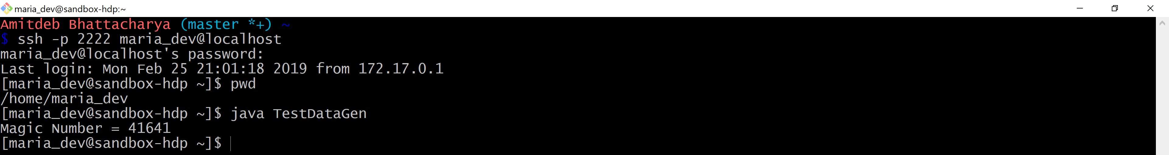

**Step A:**

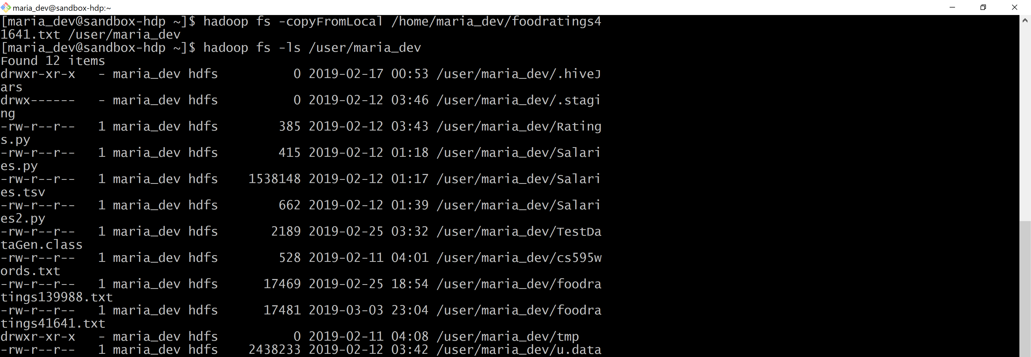

**Step B:**

*Code:*

pyspark

from pyspark.sql.types import *

struct1 = StructType().add("name", StringType(), True).add("food1",IntegerType(), True).add("food2",IntegerType(), True).add("food3",IntegerType(), True).add("food4",IntegerType(), True).add("placeid",IntegerType(), True)

ex1_foodratings = spark.read.schema(struct1).csv('/user/maria_dev/foodratings41641.txt')

ex1_foodratings.printSchema()

ex1_foodratings.head(5)

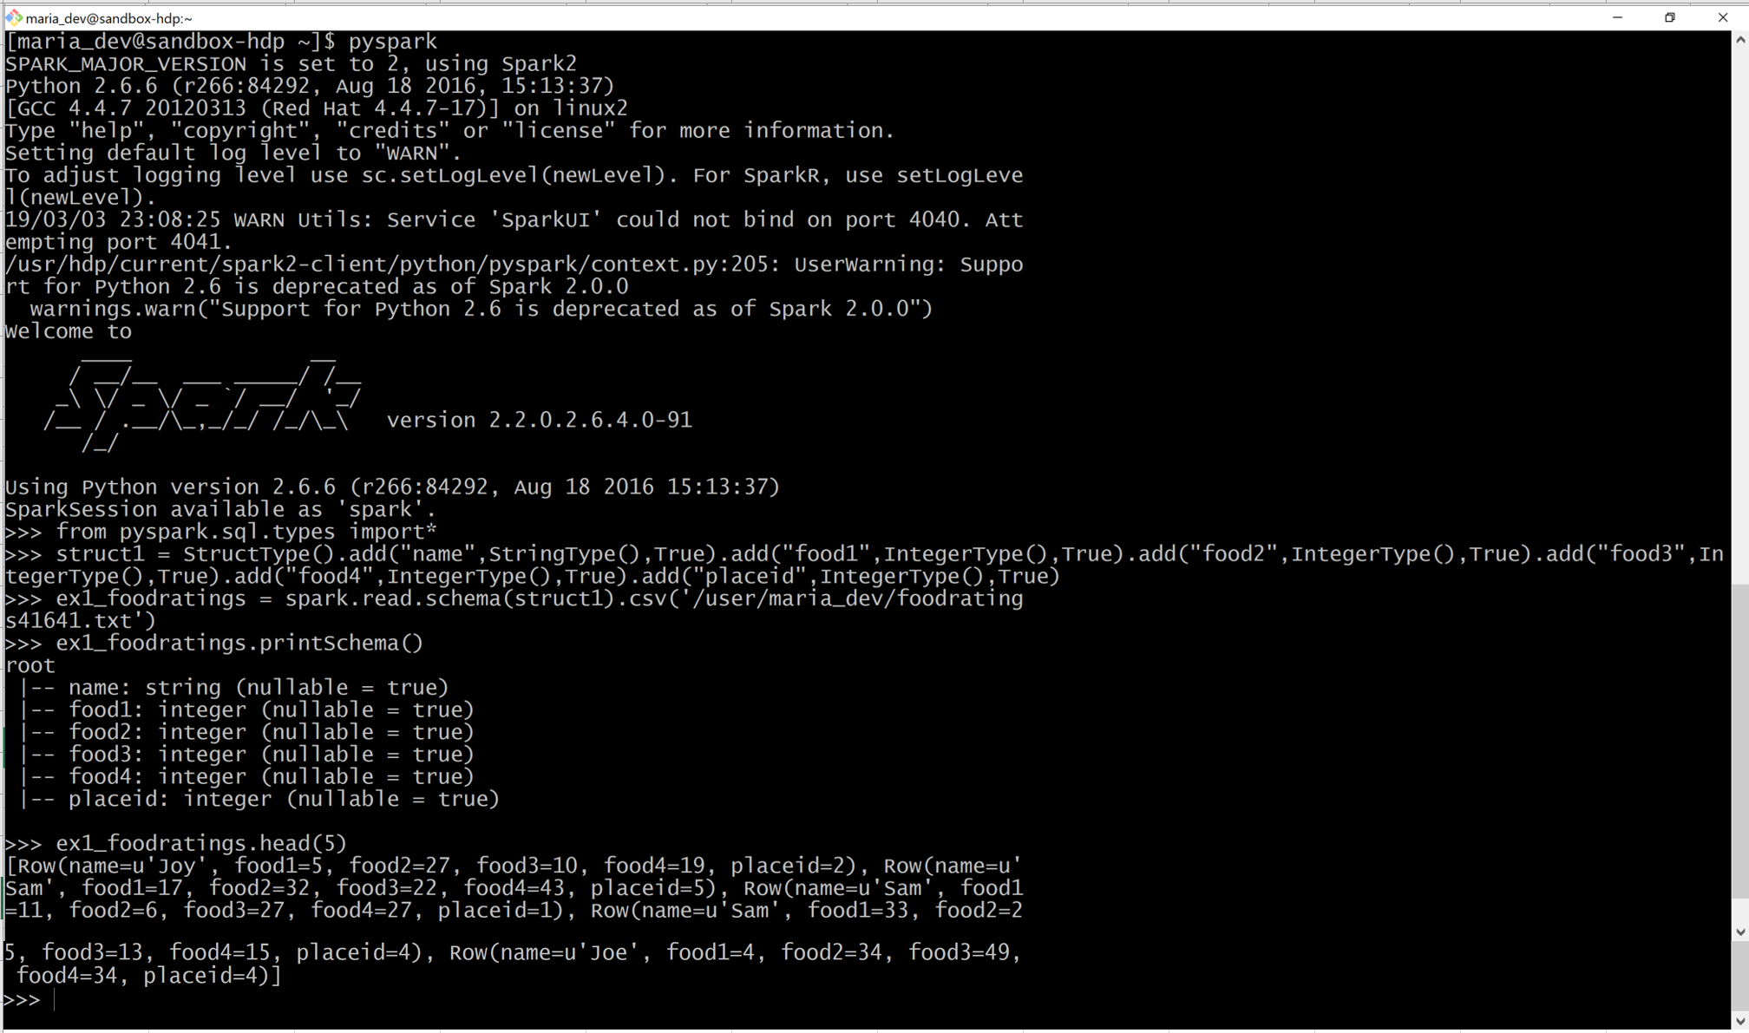

Exercise 2)

Load the ‘foodplaces’ file as a ‘csv’ file into a DataFrame called foodplaces.

As the results of this exercise provide the code you execute and screen shots of the following commands:

foodplaces.printSchema()

foodplaces.head(5)

Code :

pyspark

from pyspark.sql.types import *

struct1 = StructType().add("placeid", IntegerType(), True).add("placename", StringType(), True) foodplaces = spark.read.schema(struct1).csv('/user/maria_dev/foodplaces41641.txt')

foodplaces.printSchema()

foodplaces.head(5)

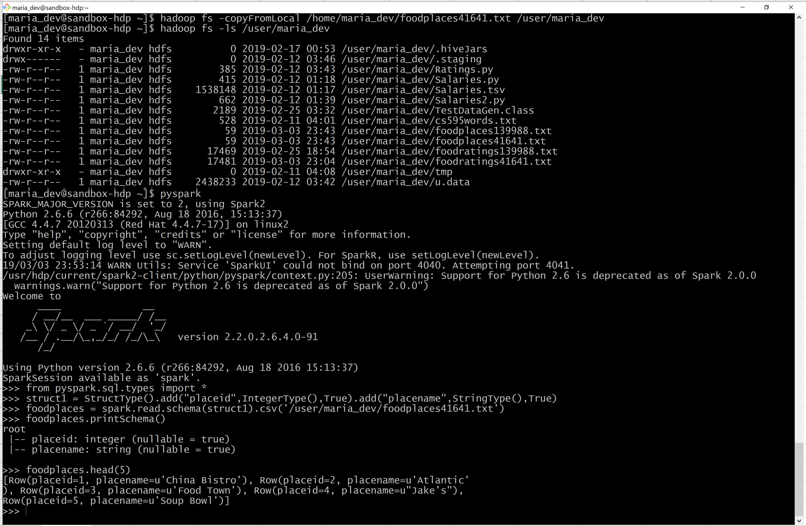

Exercise 3)

Step A) Register the DataFrames created in exercise 1 and 2 as tables called “foodratingsT” and “foodplacesT”

ex1_foodratings.createOrReplaceTempView("foodratingsT") foodplaces.createOrReplaceTempView("foodplacesT")

Step B) Use a SQL query on the table “foodratingsT” to create a new DataFrame called foodratings_ex3 holding records which meet the following condition: food2 < 25 and food4 > 40

Code:

foodratings_ex3 = spark.sql("SELECT * from foodratingsT where food2 < 25 and food4 > 40")

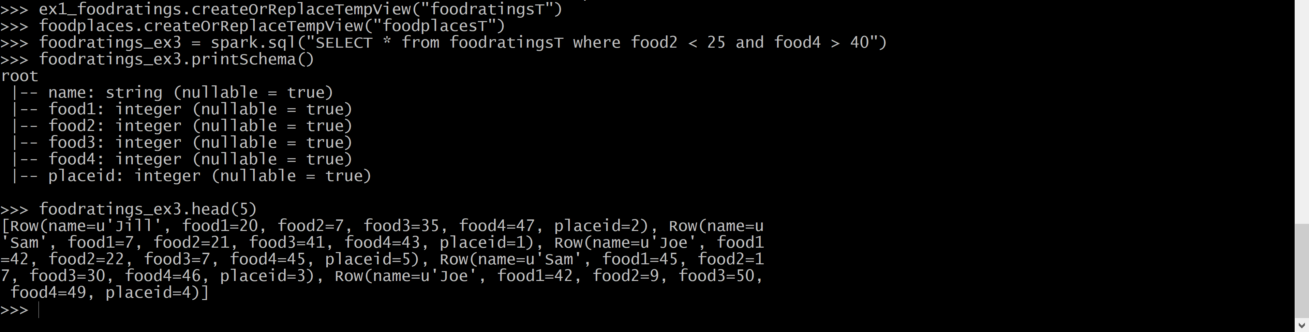

Step C) Use a SQL query on the table “foodplacesT” to create a new DataFrame called foodplaces_ex3 holding records which meet the following condition: placeid > 3

Code:

foodplaces_ex3 = spark.sql("SELECT * from foodplacesT where placeid > 3")

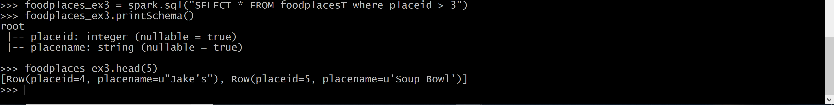

Exercise 4)

Use an operation (not a SQL query) on the DataFrame ‘foodratings’ create in exercise 1 to create a new DataFrame called foodratings_ex4 that includes only those records (rows) where the ‘name’ field is “Mel” and food3 < 25.

As the results of this step provide the code you execute and screen shots

Code:

foodratings_ex4 = ex1_foodratings.filter(ex1_foodratings.name == "Mel").filter(ex1_foodratings.food3 < 25)

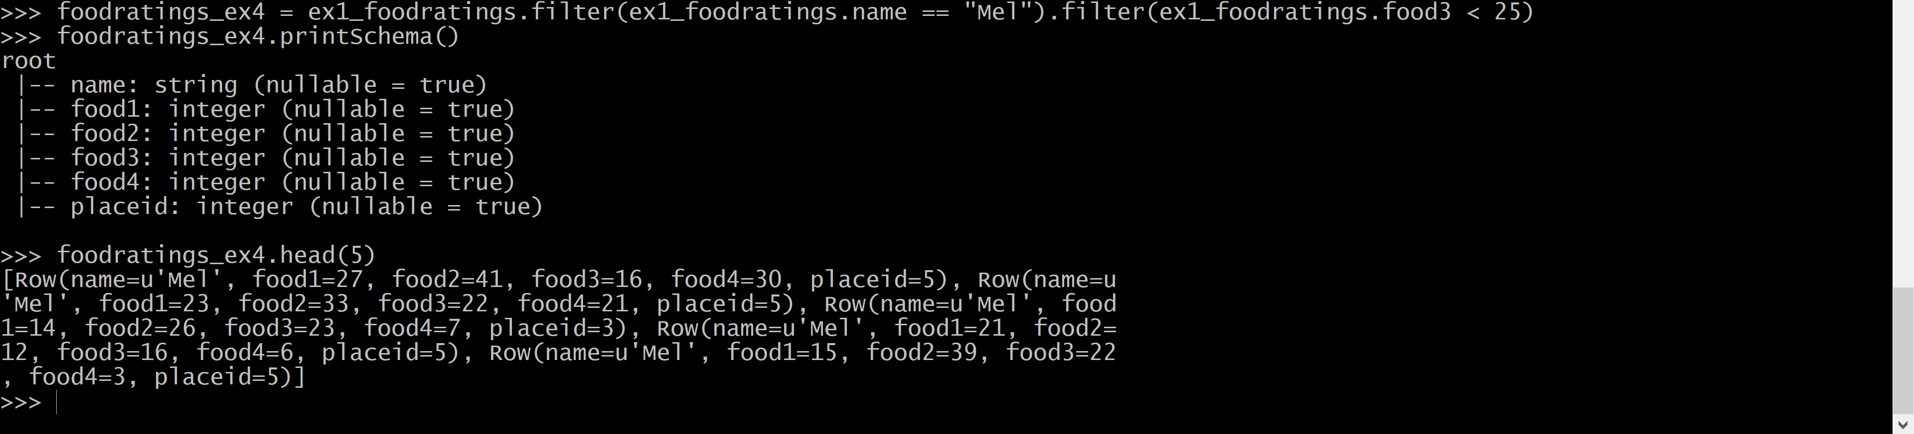

Exercise 5) Use an operation (not a SQL query) on the DataFrame ‘foodratings’ create in exercise 1 to create a new DataFrame called foodratings_ex5 that includes only the columns (fields) ‘name’ and ‘placeid’ As the results of this step provide the code you execute and screen-shots

Code:

foodratings_ex5 = ex1_foodratings.select(ex1_foodratings.name, ex1_foodratings.placeid)

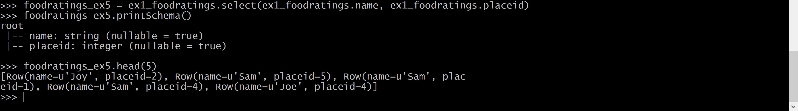

Exercise 6) Use an operation on the DataFrame ‘to create a new DataFrame called ex6 which is the inner join, on placeid, of the DataFrames ‘foodratings; and ‘foodplaces’ created in exercises 1 and 2 As the results of this step provide the code you execute and screen-shots.

Code:

ex6 = ex1_foodratings.join(foodplaces, ex1_foodratings.placeid == foodplaces.placeid, "inner").drop(ex1_foodratings.placeid)

